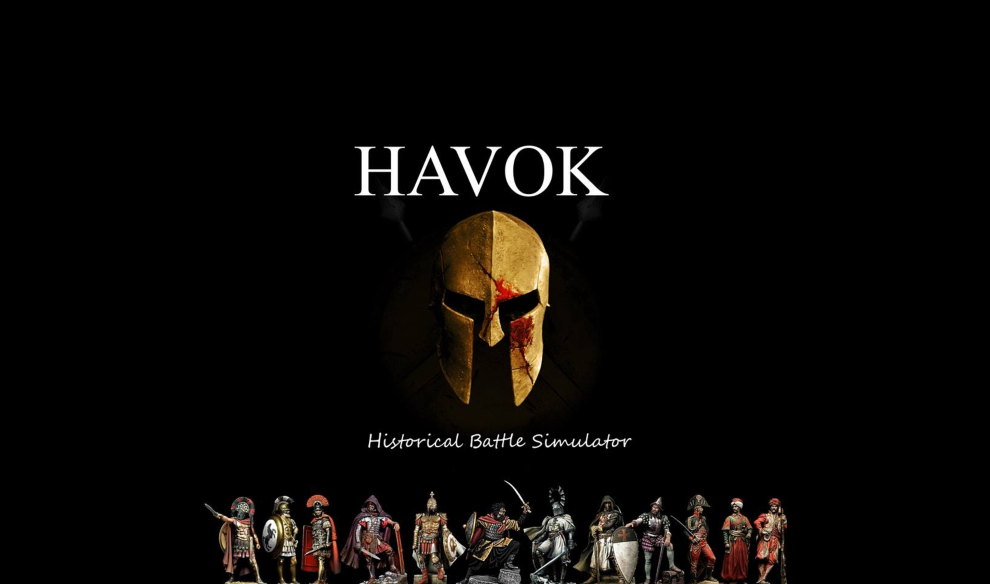

By: Edward Schmalz and Andrew Phillips

May 9, 2014

Table of Contents

Title Page………..………………………………………………………………………………1
Description of Project…………………………………………………………………………...2
Why was this Project Chosen?………………………………………………………………….2
Functional Requirements ……………………………………………………………………...3-5
Non Functional Requirements…………………………………………………………………..5
Use Cases………………………………………………………………………………………..6
Future Work……………………………………………………………………………………..7
Diagrams……………………………………………………………………………………….8-10
Design Description…………………………………………………………………………….10
Additional Help………………………………………………………………………………..10
Post Mortem………………………………………………………………………………......10-11
Manual…………………………………………………………………………………………11-20

Description of Project
The Historical Battle Simulator (HBS) uses Java to recreate historical battles from a top down turn-based point of view. The game allows players to take on the role of generals from antiquity to early modern warfare, and through an intuitive turn based system, lead there troops to victory or defeat against another player. The play style is simple, but allows players a better understanding of what challenges different military forces faced throughout history.
The HBS also includes the ability for an instructor to construct units, maps, and scenarios and save them. Both the map creator and unit creator methods rely on the instructor to place units and map tiles on the grid-based screen. The unit creator, on the other hand, allows the instructor to create a unit, choose an icon to represent it, and give it the appropriate stats. Whereas the gameplay is intuitive, understanding how to create units so that they are as close to their real-life counterparts will require the instructor to look at some tables in order to understand the system.
Finally, the HBS features some pre-generated scenarios, made by our team, that allow players to take roles in epic historic battles, such as the Battle of Agincourt or Waterloo.

Why was this Project Chosen?

We choose this project because we believe that there exists a need for new and engaging ways to communicate history and promote critical thinking in students. Although we do not seek to replace conventional methods of teaching, we believe that there is an important need to adapt the classroom to the technologies of the 21st century. It is our hope that this project will give instructors another way to present historical situations in a simple, straightforward manner that will allow students to get a first hand experience of what a battle may have been like in reality, and the strategic constraints placed on commanders. It is possible however, that if an instructor were to use this program in classes it would be as a sort of reward toward the end of a period, as it is naturally engaging and could be used to present scenarios discussed in the lectures before hand.
Due to both of our loves of strategy games, computers, and history, this was the ideal undertaking for us. As we have interest in military matters and education, the combination of the two in a program was a very appealing task. We also further hoped that by developing this program we could gain some more experience in developing educational software and turn based strategy games.

Requirements Specification

Functional Requirements

On a very basic level this product is required to do two things:

  - Build a Military Scenario
  - Execute the Scenario

However, both of these can be expanded into further parts, complete with there own requirements, both on the development side and of the user.

Build A Military Scenario

Create Units
Include All Stats, complete with description of what exactly the stats are.
Save the Unit as part of an 'army'
Allow the Unit to be loaded later
Allow the user to choose a graphical representative for the unit
Create Maps
Allow the User to place tiles, with different effects all over the map.
Save the map, and all tiles as a textual file*
Create Scenarios
Place units on the field of battle, and save their position along with the map and unit types.
Allow this to be loaded and executed
SYSTEM SIDE REQUIREMENTS(Creation)
Save Stats – Implemented by using output writers to output to a Text File.
Read Stats – Implemented by using file readers to take in data, parse ints and save to local variables on objects.
Create Maps – Implemented by Loading a Set of PNGs from file using mass import techniques.
Save Maps – Implemented by using an ArrayList of Tiles added.
Create Scenarios – Implemented by Loading Stats and a unit placing functionality.
Load Scenarios – Implemented by reading in text files of Scenario.

Execute Military Simulation

GUI – GUI should allow for the graphical representation of all movement, attacks, units and etc.
Get User Input
Mouse Position
Tile Selected – It is essential that we be able to know which tile has been selected for attacking, moving, and unit (and tile) placement.
Unit Selected – It is essential that the user be able to select unit, which will than cause a panel to show up on the bottom of the screen for them to select an action.
User Panels – As opposed to getting input from scanners or simple mouse clicks, we use button panels that call a variety of methods.
Selected Unit Panel – A transparent panel with buttons for a variety of actions. Due to the complexity of most of the buttons, many of them result in further panels.
Attack Panel – Should open up another panel which will contain all units in range for the unit to attack. This should be generated by doing a loop of all units within the range of the selected unit.
Defend – Should set the unit 'defending' which grants them a bonus to their armor class when they are attacked. Different ways of defending may be added.
Check Stats – Should open a panel in the top right with the units statistics visible.
Move – Should open up a compass pane, which allows units to move North, NorthEast, East, SouthEast, South, SouthWest, West, NorthWest.
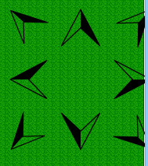
Set Formation – Should open a panel revealing the different formations that a unit can be set in. Switching units should cost one 'point'.
Example Formations: Square, Line, Wedge
Unit Placer – This panel should be used eventually only in the scenario creator, and will allow units to be placed on a specific place.
Tile Placer – This panel should allow editing of the map, and creation of different tiles.
Units – Units are the combinations of soldiers that can be selected, moved around and etc. They must be able to be placed in different formations, move, and to attack. The majority of what they do should be executed behind the scenes.
Soldiers – Soldiers are the backbone of the unit, and thus the player and thus the game. When unit creator is called, they are built and initialized.
Soldier Images :
Soldier Statistics:
Described in Depth in Historical Battle Simulator Unit Statistics
SYSTEM SIDE REQUIREMENTS(Military Scenario):
Calculate Combat – Implemented with Random Number Generators and comparisons.
Store Stats Data – Implemented with Arrays and Private Variables
Display Images – Implemented with Graphics2D

Non Functional Requirements

Fluidity – The combat system and movement system should operate in a smooth and non-obtrusive way. The program should never be to complex for the user to engage in.
Interactivity – Combat should remain interactive for the players, throughout the entire duration, and the appeal of combat should not end upon first contact between units. This is to say, that battles between two units should not simply be dice rolling match for many rounds on end.
Educational – The program should be able to host and allow for any historical scenario to be played out, prior to the invention of automatic weapons and airplanes.

Use Cases
Player
Cancel
Selection

Attack

Select Unit
Play Game

Move

Defend
Special Ability

Sprint

Check Stats

Player 1

Save

End Turn

Player 2

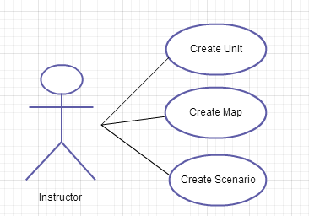
Instructor

Future Work

We would like to implement more statistics, and build more scenarios. We hope that with this project we can lay the groundwork for what can be used by instructors to build many many battles. We would like to implement a morale system, as well as a database for all the units and scenarios being created, so instructors could use other peoples ‘builds’.

We further hope that we might improve the graphics and perhaps switch the language that we use. While Java works for our purposes, this program could be improved a lot if we utilize Unity or other more game centric languages.

Additionally, we hope to get other programmers involved and set the project to be open source, so all interested can contribute. As we are not looking to profit from this, we would be happy to share credit. Also, we would like to set this up as a Facebook game at some point, or adapt it to the Ipad, so it might be more useful in classrooms. We would love it if it could be played over the network between multiple players.

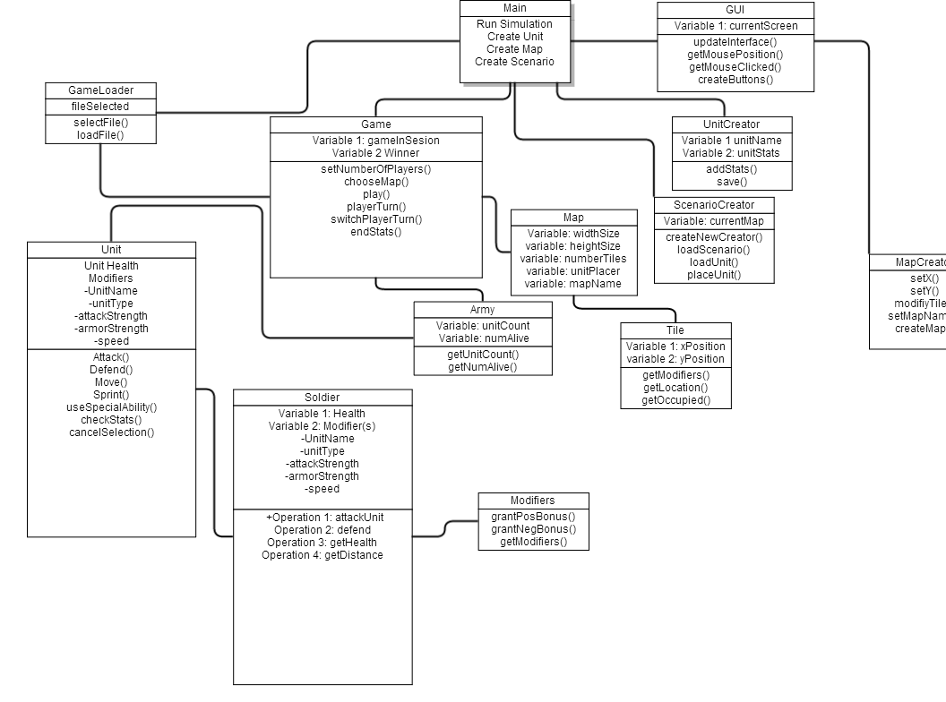

The Class Diagram

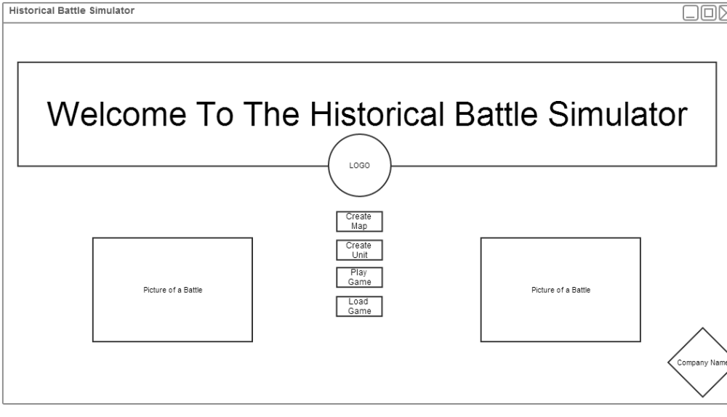
The opening menu screen
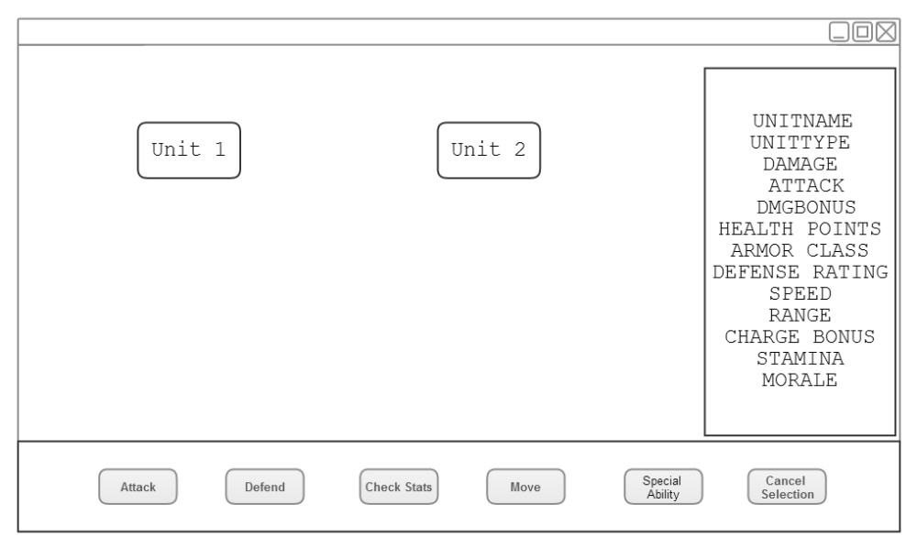
What user sees when a unit is selected and check stats is clicked

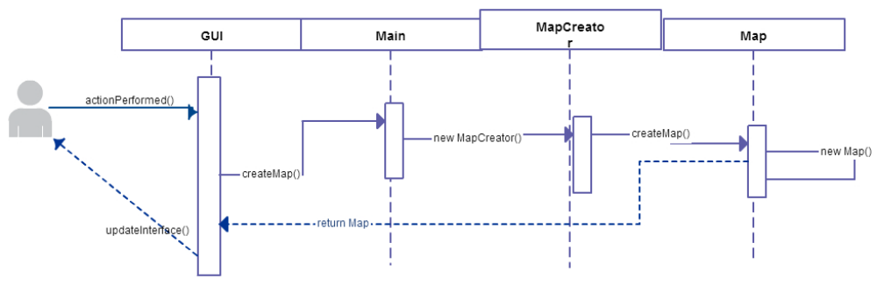

Sequence Diagram for Creating a Map

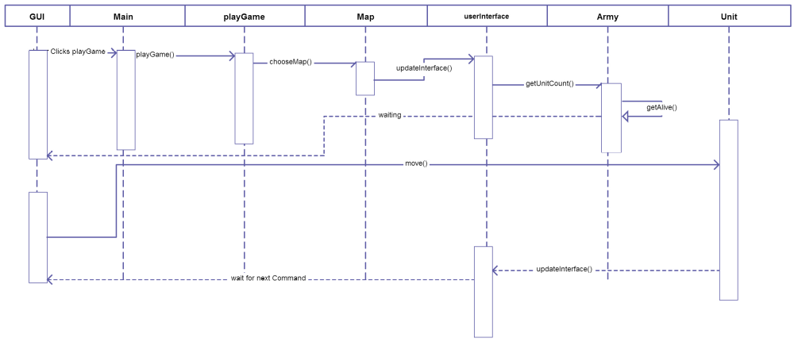
A sequence Diagram for Play Game, initialization and a move command

Design Description
The project has been implemented much in the way that we described earlier along with the system requirements. It is essentially split in such a way that the design part (Character building, map building, scenario building) are one essential part, and the actual playing of the game, is another. However, there is crossover, as the static GUI is used for both.

While it would have been more convenient and faster for us to simply develop some preset scenarios embedded in the code, creating textual files representative of these things provides us with a more versatile product.

We distributed the code for this into three different buttons on the main screen, and set them up to execute simple save methods. Furthermore, we used a variety of buffered loaders to load images, as well as image icons. Overall, these three requirements are exceptionally important and essential to what defines this project as an educational technology to be used by instructors, and not simply a game to be played.

Additional Help
Tanner Stahara, a Benedictine artist, is currently designing some cover art to replace the title page. As of now, the images are taken from Deviant Art and drawn by Phoenix8341.

Post Mortem
Andrew:
With a project this big, there are bound to be things to discuss upon its conclusion. Let’s start with the overall problem with our project, it was huge. Not only were we to create a fully functioning game (a very tall task already) we also decided that it should have the ability to let users create more instances of the game. Now, while a semester of time probably would have been enough for two experienced programmers with eight hours a day to get this project done with all the bells and whistles included, two inexperienced full time college students with way less than eight hours a day to work on this project did not have a very good chance of finishing this to 100% completion on time.

Second, after some discussion early on in the project, we decided not to use a game engine (like Unity). We largely decided this because we would have to learn how to function with C# or JavaScript and did not want to add learning a new language onto our already big project. A prebuilt game engine would have allowed us to use the structure it provided to implement what we wanted and not have to build everything from scratch. If we could have gotten a grasp of it quickly enough, we think that the game aspect of our project would have been more polished.

Edward:
We believe that this product could have been executed more efficiently if we had figured out our requirements from the beginning and approached them as such. As it was, we(mostly I) got a bit caught up in feature-creep and got more involved in adding some small things that were not essential to the project(For example the fully functioning detailed statistics system). If we had instead focused centrally on a simpler system and getting it working, we could have gone from there. Nonetheless, I think that this project has more potential, and look forward to fiddling with it in my spare time.

Also, we HATE GitHub. We aren't sure what would have been more effective, but we had no problem with GoogleDocuments or DropBox, but for some reason GitHub gave us a huge amount of problems.

Historical Battle Simulator
Manual

Welcome to the Historical Battle Simulator! We hope you are as excited as we are about getting a chance to step into the shoes of some of the greatest generals and admirals! Will you recreate battles in historical order? Or will you play as the Napoleon who wins at Waterloo? The choice will be yours!

I. Playing The Game
This section is intended for students
Choosing A Scenario

The first thing you will notice when you click is a folder displaying a variety of different scenarios. Each of these scenarios have either been created by your instructor, or by our production team. Either way, the titles should be fairly self-explanatory (e.g. Agincourt1415.txt, Waterloo.txt).

Once you select the campaign that you are going to play, the game will set you against your classmate and the two of you will get a chance to battle!

Display
Therefore, chances are you are currently looking at a field that looks something like this:
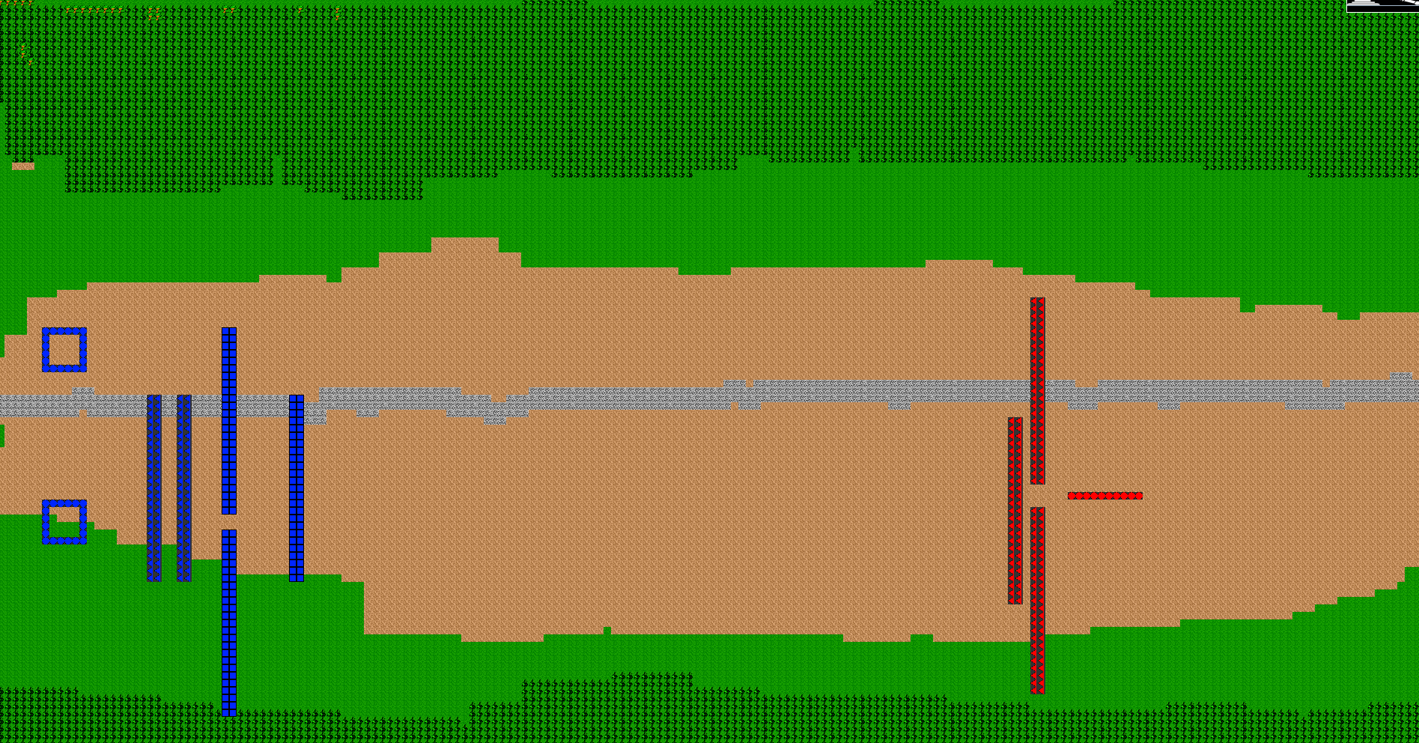
As you may have guessed, this is the recreation of the scenario! However, you may understandably be having difficulty understanding what is going on.

Icons and Symbols

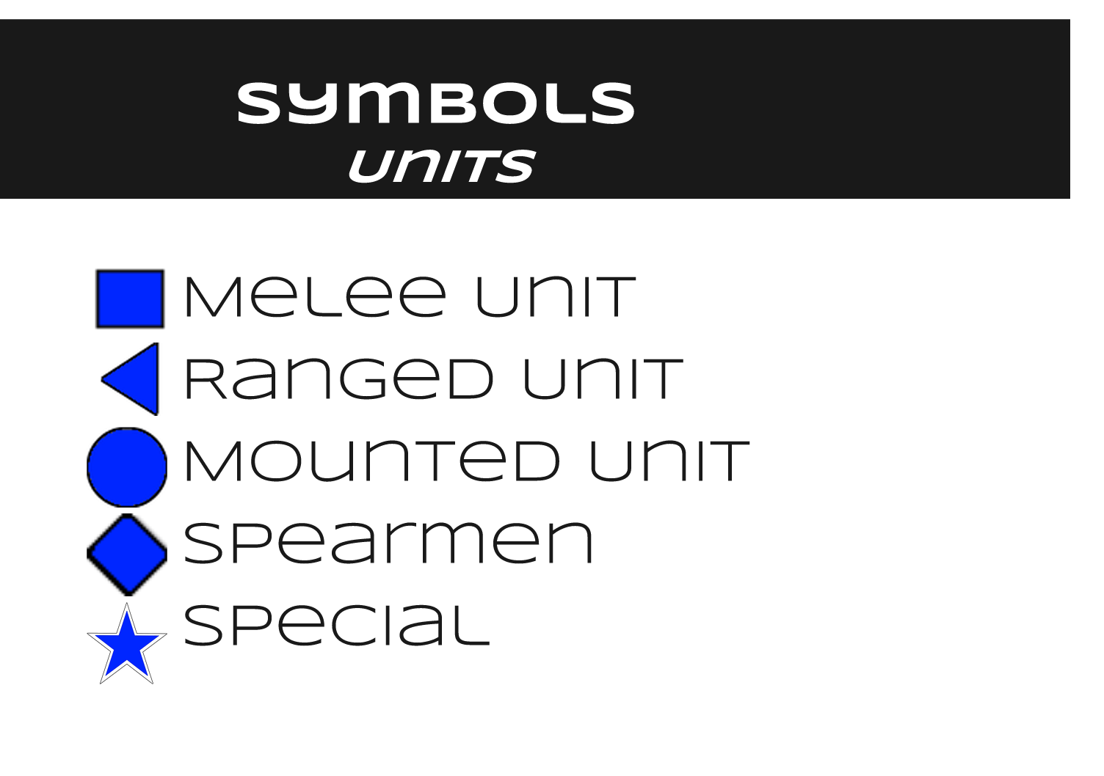
The icons displayed above give a good idea of what exactly each of these symbols mean. But what are these exactly?
Melee: Melee is someone who fights in hand to hand combat! The quintessential tough guy of warfare, they come in all shapes and sizes.
Ranged: Typically wielding a bow, gun, or javelins, the ranged class prefers to attack from a distance, relying on their accuracy.
Mounted: These are units on horses, cars or anything of the like. They move much faster than units that are walking and are a dangerous force on the battlefield.
Spearmen: These are those who wield spears! A long pointy stick may sound crude, but for thousands of years they dominated the battlefield.
Special: Some units don’t fit into the aforementioned types. This may be a general, a siege engine operator, or someone who doesn’t fit into the other classification.

Although units can be colored one of many colors, but these symbols are used to represent units throughout the whole game. All other symbols represents terrain features. For example, green is grass, brown is dirt, trees represent trees and blue is water.

Turns
Each time you take a turn, all of your units’ ‘unit points’ (the amount of actions they get to execute) will be reset to two. This means you can do two of the things that appear on the menu when you select a unit. This will generate the following:
Each of these buttons has a crucial role to play in the battle.

Attack: Opens a menu including all of the units with in the selected unit’s range. That is to say, everyone that they can hit! Opening this up brings you into combat.

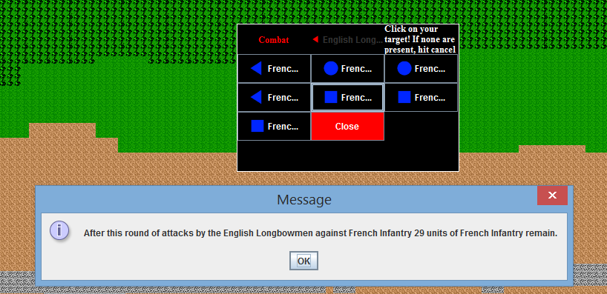
Defend: This causes a unit to brace themselves, put up their shields if they have them. It gives them a bonus against any attack on them.

Check Stats: Gives you the numbers on what the selected unit’s statistics are.

Move: Opens the following panel to allow you to guide a unit for their selected amount of tiles. This amount is stored in the ‘Speed’ value of a unit.

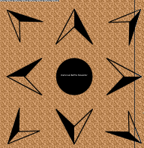
Note: Sprinting can be done by selecting the button in the middle! This allows your units to move twice as far in a turn, but will use up their stamina the more you do it.

Set Formation: This opens up a menu and allows you to choose what formation you want your troops to be in. Prior to the invention of automatic weapons, formations dominated warfare! Disciplined soldiers who could hold formation were the most valuable and were very effective on the battlefield! A unit that stood together and charged would cause a lot more damage than a loosely dispersed group for instance, and a unit that held a square would be able to fight off a cavalry charge more effectively.

For our uses, we have the following formations available:
Column: This formation exposes just the front to the opposing army. It is good for approaching through a small pass.
xx
xx
xx
xx
xx
xx

Row: This formation exposes the broad face to the opposing army. It has the most ‘surface area’ exposed to the enemy.
e.g.
xxxxxxxxxxxxxxxxxxxxxxxxxxxxx
xxxxxxxxxxxxxxxxxxxxxxxxxxxxx

Square: This formation is, as you may have guessed, a square. It is the best defensive formation and used to hold a position and defend it from both sides. It is particularly good against cavalry.
e.g.
xxxxxxxxxxxxxx
xx xx
xx xx
xx xx
xxxxxxxxxxxxxx

Cancel Selection: This button exits you out of the selection method and allows you to select another unit.

II. Creating Units
This section is intended for instructors.

To create a unit, select the button. This will open up the menu and allow you to fill in the data. All of the data values are explained in the following document.

The following document is meant to explain the different components of a unit, and the statistics associated with them.
Unit Name:
The name of the selected unit. This name should refer to its general name. It can also include adjectives such as country or region names to denote what sort of unit it is.
E.g.: Cretan Archers, Longbowmen, Spartan Hoplites, General’s Bodyguard
Unit Type:
The type of unit being referred to. This is denoted as an integer between 1-5. The values are as follows.
1: Melee : Melee units fight in hand to hand combat. They wield weapons such as shields, swords, knives, axes and the like as their primary weapons.
E.g.: Roman Leggionares, Germanic Berserker, Dismounted Knight
2: Ranged: Ranged units fight from a distance. They wield weapons such as bows, arrows, sling and guns. They typically attempt to keep their distance from their opponents at all costs, as they are typically weaker in direct combat. Siege weapons fall under this category, although they are typically slow moving.
E.g.: Cretan Archers, Longbowmen, Velites, Slingers, Ballista
3: Cavalry: Mounted melee units. These units are fast moving, and typically get a bonus to charge as a result of their bonus. They are especially effective against ranged units because of the ranged units typically lower armor.
E.g.: Roman Auxiliary Cavalry, Heavy Cavalry, Light Cavalry
4: Spearmen: Melee units that wield long pikes of some sort. These units are exceptional at defense typically, and can damage cavalry very effectively by using formations such as ‘pike walls’ and ‘phalanax formation’. These units are most effective in tight formation. However, they move slower and may make easy targets for siege weapons or archers.
E.g.: Spartan Hoplites, Colonial Militia Pikeman, Barbarian Pikeman
5: Special: Units that do not fit into the traditional schema laid out above. This may include units that are hybrids of the others.
Attack(ATK):
This value refers to the bonus that is given to the soldiers chance of hitting their opponent. It is a bonus meant to be added to a randomly generated integer between 1-20, which compares against the units defense. It is a product of the soldiers expertise and training. For instance, a very precise marksmen would have a high bonus, while a clumsy one would not. A basic way of understanding the bonuses is visible in this table.

Value | Examples
-5 | The efficiency of wielding a sword with your bad hand after breaking both your arms.
-4 | A very clumsy wielder, perhaps a child who has picked up his fathers sword
-3 | Unlikely to hit anyone except the worst defended people.
-2 | A dazed warrior, or a novice person attempting to use a weapon they I’ve never used. An untrained peasant might have this  bonus
-1 | A slightly below average warrior
0 | Average
1 | A slightly experienced soldier, perhaps a militia trained swordsman
2 | A regular of an army would likely have this bonus
3 | An attack focused unit, such as a longbowmen might have this bonus
4 | The most elite forces of an army may have this bonus
5 | The best of the best

Damage (DMG):
This number refers to the range of which a unit can do damage. In a tabletop game this would
refer to the amount and type of dice that would be rolled to determine the damage dealt. The damage dealt will be subtracted directly from the HP of the opponent. This is based mainly on the type of weapon. For
brevity’s sake, ‘dice’ refers to the range of numbers that the damage is randomly generated from.

Dice | Weapons
1 to 4 | Hand to hand combat, slings, thrown rocks and daggers, small daggers, shuriken
1 to 6 | Short swords(Roman Gladius), short bows, one handed axes1
1 to 8 | Javelins, one handed spears, long bows, basterd swords
1 to 10 | Two handed swords, two handed axes, crossbows
1 to 12 | Muskets, basic rifles
1 to 18 | Ballista shooting flaming bolts, cannonballs

Damage Bonus:
This number refers to the bonus applied to the characters damage if they get a ‘hit’. It is based on components such as the specific make of the weapon they use, or the training and strength. A barbarian axe wielder for example may get a very large bonus here, although there clumsy style may make it harder
for them to hit another unit.

Value | Examples
-5 | A very weak man attempt to hit something with a very flimsy sword
-4 | A weak person or weapon
-3 | The weapon is very damaged
-2 | A weapon that is damaged, or that the person wielding it does not know how to use.-
-1 | A slightly below average warrior
0 | Average
1 | A milita of the army may have this bonus, if they are equipped with average weapons
2 | A regular of an army would likely have this bonus, if equipped sufficiently.
3 | An attack focused unit, such as a longbowmen might have this bonus
4 | An damage focused unit, such as a berserker might have this bonus, if equipped  sufficiently.
5 | The best of the best at doing damage, with the best weapon.

Hit Points(HP):
The amount of health an average character has. This value decreases when the unit takes damage. It is based on the strength and health of the individual person, but on average units usually have approximately 10 health. Since the average weapon does around 6-12 damage, units who sustain any amount of direct hits are likely to be reduced to wounded(a condition that occurs at half health and has negative bonuses on all actions) and killed much quicker. The average values for the main unit types are
as follows:

Value | Type
15 | Spearmen
12 | Cavalry
10 | Melee
7 | Ranged
5 | Peasant

Armor Class(AC):
This refers to the overall defensive value, or ‘armor class’ of a unit. It is the number that the attacker is attempting to ‘beat’ when they attack. It is a constant value, which gets a bonus based on if the unit is ‘defending’ or in defensible terrain. This is a mixed value, so one unit may have a high AC based on there heavy armor, while another might have one because of their speed and agility making them hard to hit.

Value | Examples
1-5 | A prone and vulnerable target.
6 | Children, peasants, etc.
7 | Armed peasant, no armor
8 | Levy spearmen, levy javelin bearer, no armor.
9 | Militia(cloth wearing)
10 | Armored militia (Some leather), Velite, Bowmen
11 | Gallic warrior(leather armored)
12 | Persian mercenrary (Some chainmail, some leather)
13 | Crossbowman (all chain mail), Pikeman
14 | Roman soldier (Some chain mail and plate, shield wielding)
15 | Hoplite, knight(mostly plate, a shield)
16 | Full plated knight
17 | Specialty plate
18 | Scalemail
19 | Modern body armor
20 | Batman
Defense:
This value is a bonus added when a unit is ‘defending’. It gives the unit a higher AC when they get attacked, if they have selected to defend. Units have a much higher defense value if they posses shields.

Value | Type
1 | Average (no shield)
2 | Buckler
3 | Kite shield
4 | Square shield
5 | Hoplite Shield

Speed: The amount of tiles that a unit can move in a turn. Each tile represents a 5 by 5 foot square. This is the amount of ground that a unit can cover in 5 seconds. The average speed is 5 squares. When a unit sprints, they expend a stamina point and double their speed for the turn.

Speed | Example
1 | Trebuchet
2 | Ballista, scorpion, injured soldier, pikeman in formation
3 | Soldier in heavy armor, mobile pikeman
4 | Soldier in chain or leather
5 | Lightly armored soldier
6 | A scout or archer or heavy armored soldier
7 | An injured mounted unit
8 | A sprinting soldier in medium armor
10 | A sprinting lightly armored soldier. Slow mounted unit(Elephant)
12 | Average mounted unit, sprinting socut
14 | Fast mounted unit(light cavalry)
20 | Sprinting slow mounted unit
24 | Sprinting average mounted unit
28 | Sprinting fast mounted unit

Range: This value is the range of which a unit can attack. For melee units, this value is 1, referring to the amount of squares they can reach. For spearmen the value is 1.5 squares, insinuating that they can strike slightly further. For ranged units, this value depends on their weapons and personal training. Some examples are provided below.

Range | Example
1 | Average Melee
1.5 | Spearmen
3 | Javelin(most thrown weapons)
6 | Slings, shortbows
8 | Average bow, musket
10 | Longbow, Ballista
15 | Modern rifle
20 | Trebuchet
25 | Sniper rifle

Charge Bonus:
This value refers to the bonus applied to a unit’s damage when charging. For all units, charging gives them some bonus, but the larger and thus more inertia a unit has, the higher the charge bonus. Heavy cavalry units typically have the highest charge bonuses (elephants and tanks being the maximum).

Value | Example
1 | Ranged Unit, peasants
2 | Basic melee unit (basic armored foot soldier), Pikeman
3 | Heavily armored foot soldier
4 | Berserkers, shock troops
5 | Light cavalry
7 | Regular Cavalry
10 | Heavy Cavalry
15 | Elephants or tanks
Stamina:
This value refers to the amount of stamina a unit has. The more armor a unit is wearing, or the less they are physically conditioned, the less they are able to sprint. The average value, for a medium armored unit is 2. Some units may have higher stamina based on their individual training. This is up to the character designer’s discretion.

Value | Example
1 | Full plate, heavy chain mail
2 | Medium armor
3 | No armor or exceptionally trained units in medium
4 | Specially trained scouts
5 | Chuck Norris

III. Map Creator
This section is intended for the instructor.

In order to create a map, click the button. This will generate the following interface.
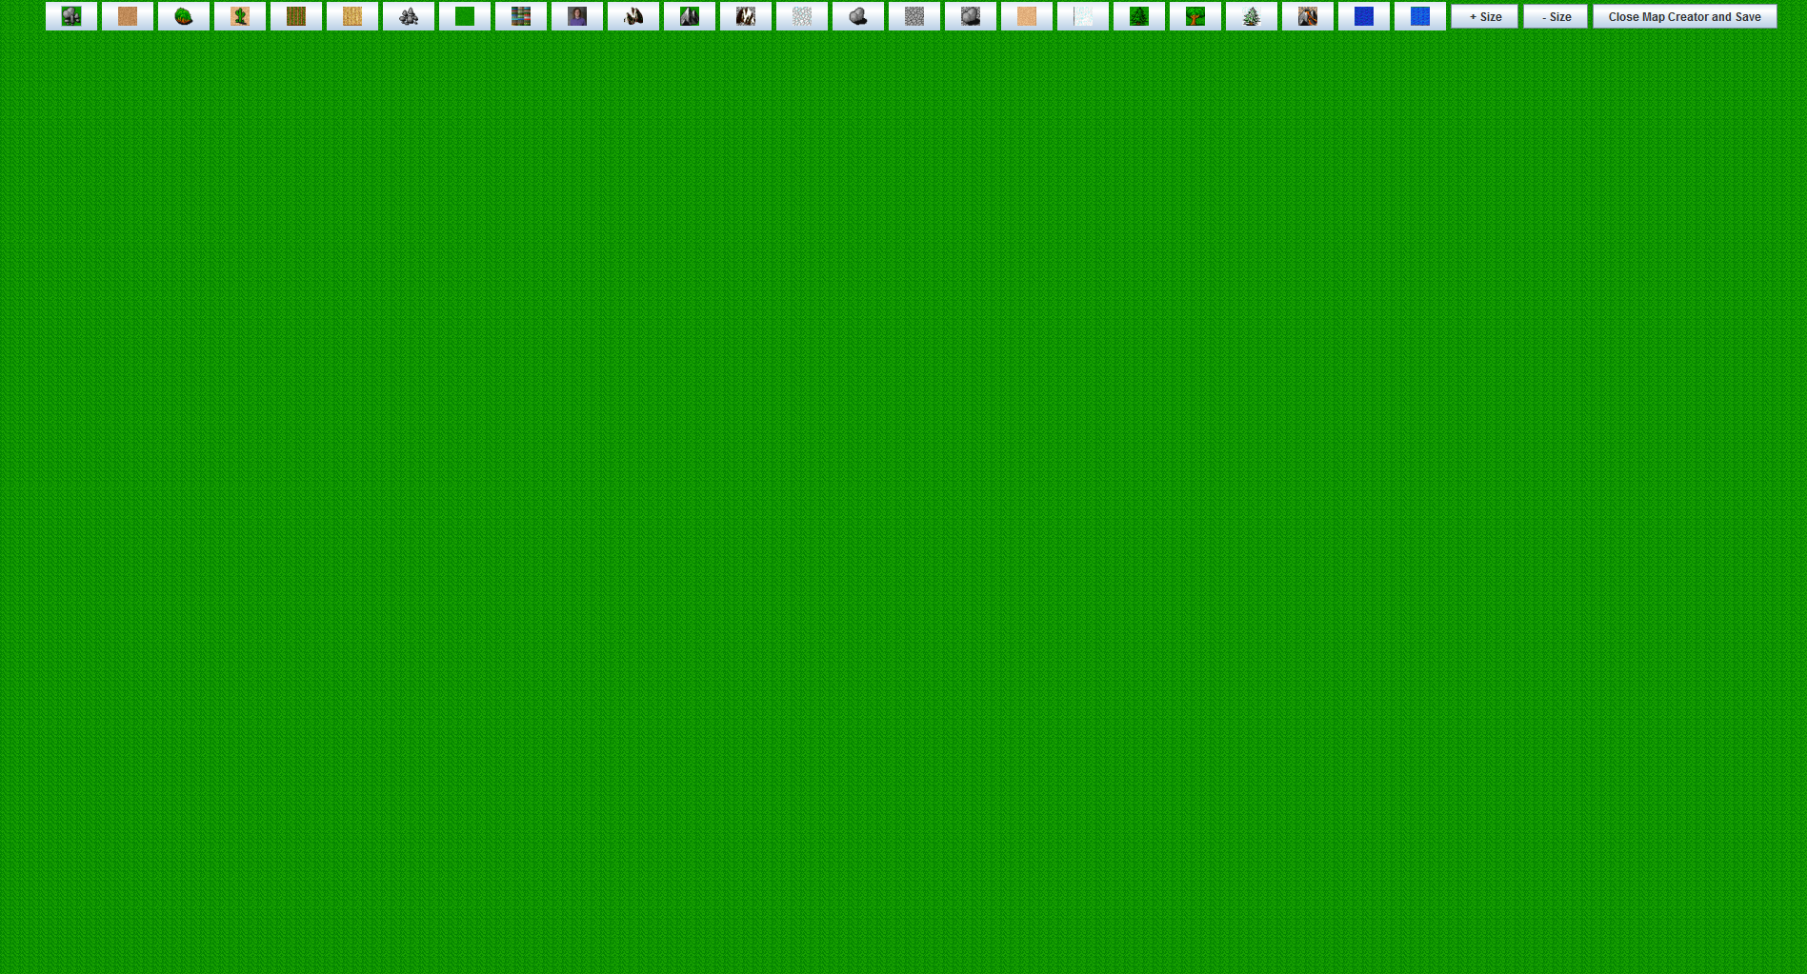
You can add terrain by clicking any of the buttons on the top:
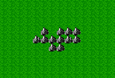
After you select this, you can click the place on the field where you wish to place the terrain.
You can also increase or decrease the size of the terrain you are placing by selecting the +Size and -Size Buttons.

When you are done, click the [Close Map Creator and Save] and write a name to save the file as.

IV. Scenario Creator
This section is intended for the instructor.
The scenario creator allows for the placement of the units that have been created on the field.

First select a Map:
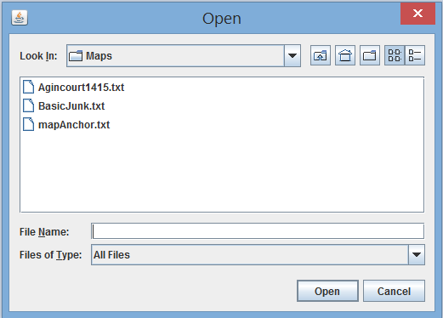
Than name each Army:
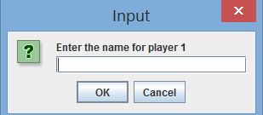
Select a List of Units:
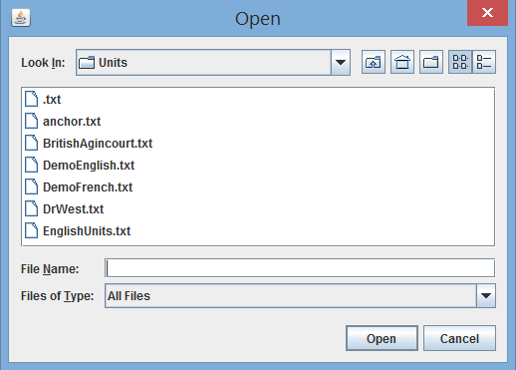
Than place them on the field of battle!
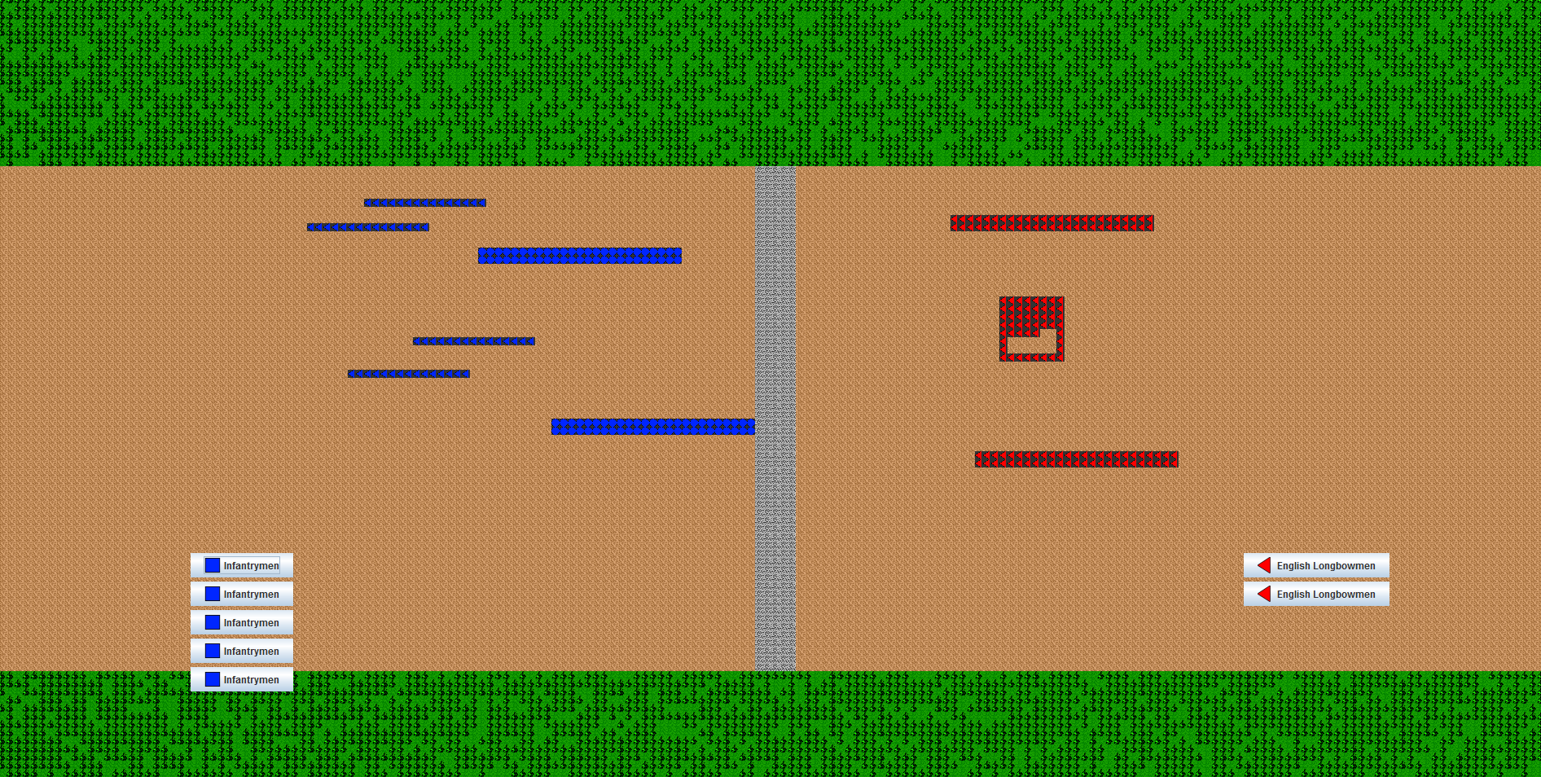

Conclusion

Good luck instructors and players! We hope that you enjoy this game as much as we enjoyed making it!

